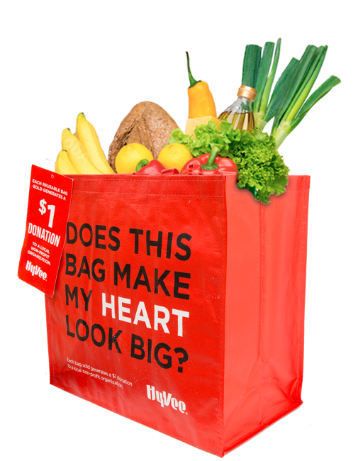

REUSABLE BAG PROGRAM

Sample Press Release

DOWNLOAD IMAGES

FOR IMMEDIATE RELEASE: [Name of organization] [Name, phone & email]

Hy-Vee Reusable Bag Program Selects [Name of organization] as a Beneficiary

[City, State] – [Name of organization] has been selected to benefit from the Hy-Vee Reusable Bag Program for the months of [month1] and [month2].

The Hy-Vee Reusable Bag Program, which launched in October 2019, facilitates community support with the goal to make a difference in the communities where shoppers live and work.

[Name of organization] was selected to benefit from the program for the months of [month1] and [month2] by store leadership at the Hy-Vee located at [location]. During this benefit period, [Name of organization] will receive a $1 donation every time the $2.50 reusable Red “My Heart” Bag is purchased at this location, unless otherwise directed by the customer through the Giving Tag attached to the bag.

“[1-2 sentence quote reflecting excitement about being chosen],” said [name], Executive Director of [name of organization]. “[Short quote on how this donation will help you fulfill mission].”

[Name of organization] is a nonprofit based in [city, state]. Founded in [year], [name of organization] has [describe efforts in the community]. Learn more about [name of organization] by visiting [website].

For more information on the Hy-Vee Reusable Bag Program, visit hy-vee.2givelocal.com.

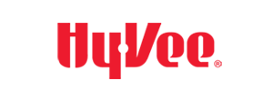
hy-vee.2givelocal.com

