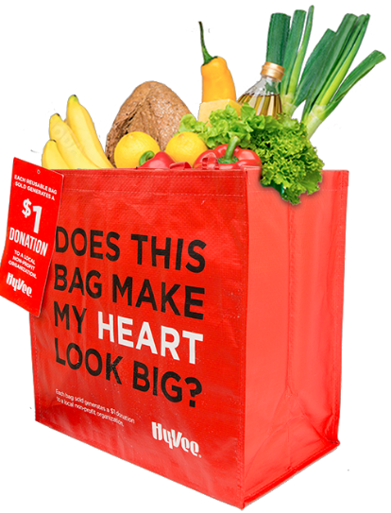

HY-VEE “MY HEART” REUSABLE BAG

Launch Day Email

DOWNLOAD IMAGES
SUBJECT: Launch Day of Hy-Vee “My Heart” Reusable Bag Program!

Hello,

Today is launch day for the Hy-Vee “My Heart” Reusable Bag Program! Starting today and for the entire months of [months of selection], when you purchase a $2.50 “My Heart” Reusable Bag at the Hy-Vee located at [location], $1 is donated to [name of organization].

Our goal is to sell [goal of bags bought e.g., 200] bags, equivalent to $[insert donation equivalent e.g., $200] raised. We are confident that with the help of our dedicated supporters, we can reach this goal.

We strongly encourage you to share this news with family and friends as well!

The “My Heart” Reusable Bags are located on displays around the store and at the checkout. For more information about the program, please visit hy-vee.2givelocal.com.

Thank you for your support, [Signature]

hy-vee.2givelocal.com

