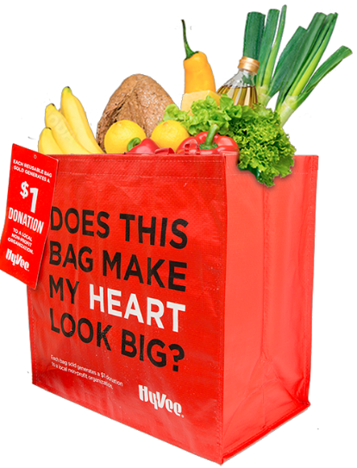



**HY-VEE “MY HEART” REUSABLE BAG**

Sample Email



[**DOWNLOAD IMAGES**](https://hy-vee.2givelocal.com/resources/bag-program-image-bank/)

**SUBJECT LINE:** We’ve been selected by the Hy-Vee “My Heart” Reusable Bag Program!

**PREVIEW TEXT:** For all of [*Month & Month*] every “My Heart” Reusable Bag purchased at Hy-Vee earns us $1!

Dear [*Staff/Board/Volunteers*],

We are so excited to share that [*organization*] has been selected to benefit from Hy-Vee’s “My Heart” Reusable Bag Program, which makes it easy for customers to contribute to their local communities.

For the months of [*month and month*], whenever a $2.50 “My Heart” Reusable Bag is purchased at the Hy-Vee located at [*location*], $1 will be donated to [*organization*]. This is a great way to broaden awareness and help our cause.

Let’s get started! Share the news with friends and family. Call, send emails and post on social media. The more people who purchase the “My Heart” Reusable Bag in [*month* *and month*], the more we can raise!

To learn more about this program, please visit [hy-vee.2givelocal.com](https://hy-vee.2givelocal.com).

Best,

[*Signature*]

[hy-vee.2givelocal.com](https://hy-vee.2givelocal.com/)