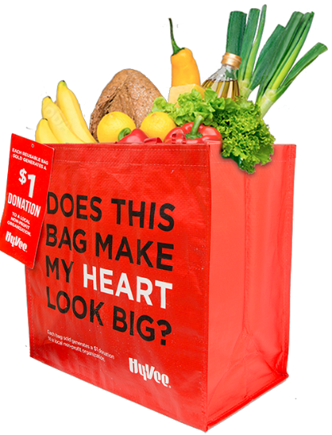
HY-VEE “MY HEART” REUSABLE BAG

Thank Your Supporters Email & Social Post

DOWNLOAD IMAGES

SUBJECT: Thank you for your support!

Hello,

Through the Hy-Vee “My Heart” Reusable Bag Program, we received $[money raised] in donations from bag sales in the months of [benefiting months]!

We extend a HUGE thank you for your participation and support during our benefiting months of the Hy-Vee “My Heart” Reusable Bag Program. Whether you bought a bag or helped spread the word, we couldn’t have done this without you. The money generated will help us to [share what you’ll do with the donations]. Thank you again for making this a fun and successful experience for [name of the organization].

But guess what? We’re not done! Anyone can continue to support [name of the organization] by visiting any Hy-Vee, purchasing the “My Heart” Reusable Bag and using the attached Giving Tag to send a $1 donation to us any time throughout the year!

Share With Your Followers
Thank you! We raised $[donation amount] through the Hy-Vee “My Heart” Reusable Bag Program! Guess what? You can still support us by visiting any Hy-Vee, purchasing the “My Heart” Reusable Bag and using the attached Giving Tag to send a $1 donation to us any time throughout the year.

hy-vee.2givelocal.com

