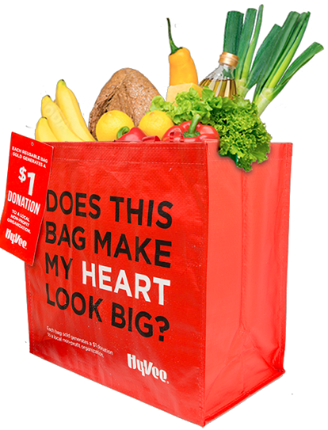

GIVING TAG PROGRAM

Thank Your Supporters Email & Social Post

DOWNLOAD IMAGES
SUBJECT: Thank you! Hy-Vee Giving Tag Program

Hello,

Thank you for purchasing a “My Heart” Reusable Bag from Hy-Vee and using its attached Giving Tag to direct the $1 donation to [name of your organization]. We’ve raised a total of $[donation amount] so far!

Whether you’ve bought a bag or helped spread the word, we couldn’t have done this without you. The money generated through this program will help us to [share what you will do with the funds raised].

If you haven’t had a chance to pick up a bag yet, don’t worry! The Hy-Vee Giving Tag Program runs all year long. All you have to do is purchase the “My Heart” Reusable Bag at any Hy-Vee and follow the instructions on the attached Giving Tag to direct the $1 donation to our organization.

To learn more about this program, please visit hy-vee.2givelocal.com. Thank you for your continued support!

Share With Your Followers
Thank you! We raised $[donation amount] through the Hy- Vee Giving Tag Program! Guess what? You can continue to support us by visiting any Hy-Vee, purchasing the “My Heart” Reusable Bag and using the attached Giving Tag to send a $1 donation to us any time throughout the year.

hy-vee.2givelocal.com

