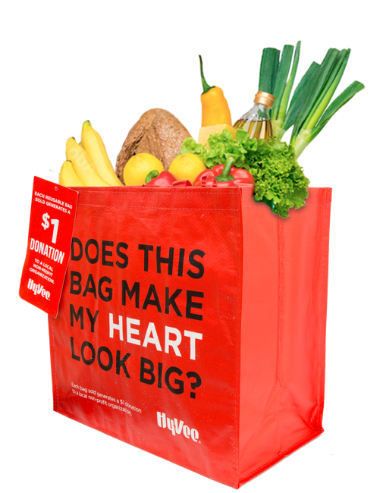

REUSABLE BAG PROGRAM

Sample Press Release

CLICK HERE FOR MARKETING MATERIALS

FOR IMMEDIATE RELEASE: [Name of organization] [Name, phone & email]

[Name of organization] has been selected as March and April’s Hy-Vee “My Heart” Reusable Bag Program beneficiary.

[City, State] – For both March and April, store leadership at Hy-Vee’s [location] location has selected [Name of organization] to receive a $1 donation from every purchase of the $2.50 Hy-Vee “My Heart” Reusable Bag.

The Reusable Bag Program facilitates community support with the goal to make a difference in the vicinities where shoppers live and work. More than $125,000 has been donated to almost 5,000 local nonprofits since the Program launched in October 2019.

“[1-2 sentence quote reflecting excitement about being chosen],” said [name], Executive Director of [name of organization]. “[Short quote on how this donation will help you fulfill mission].”

[Name of organization] is a nonprofit based in [city, state]. Founded in [year], [name of organization] has [describe efforts in the community]. Learn more about [name of organization] by visiting [website].

For more information on the Hy-Vee Reusable Bag Program, visit hy-vee.2givelocal.com.

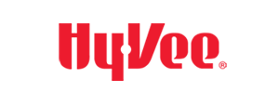
hy-vee.2givelocal.com

